**Report**

Info: Linux-5.10.146

**Program 1:**

First fork, go to child process and parent process if no error happens.

The child process executes the file, print out message related. Then, it returns status that contains information of child process.

Analyzing the status:

WIFEXITED for exited. If succeed, print related massage and exit status (using WEXITSTATUS).

WIFSIGNALED for situations that child process is terminated by signal.

WTERMSIG for signal value.

WIFSTOPPED for checking whether child process is stopped or not.

Below show the output graph:

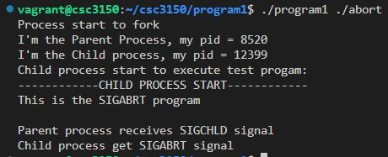

Abort

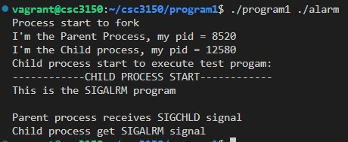

Alarm

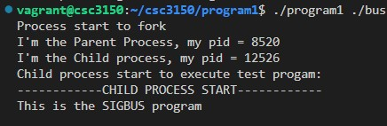

Bus

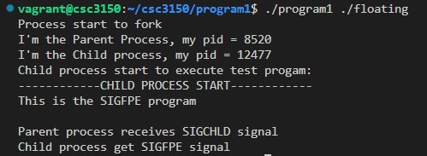

Floating

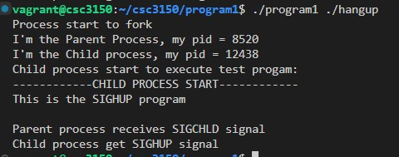

Hangup

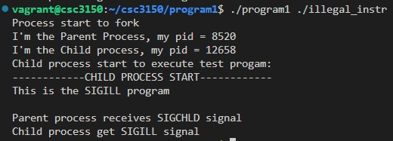

Illegal_instr

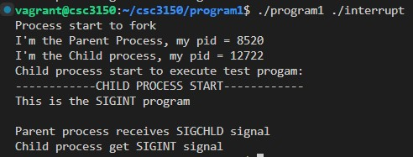

Interrupt

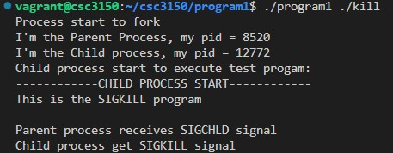

Kill

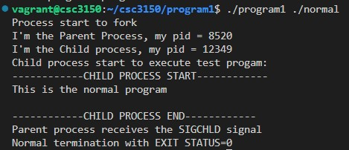

Normal

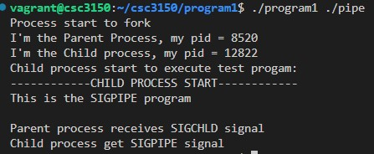

Pipe

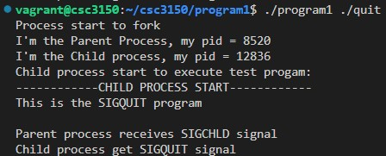

Quit

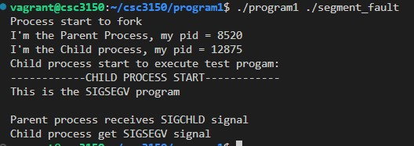

Segment_fault

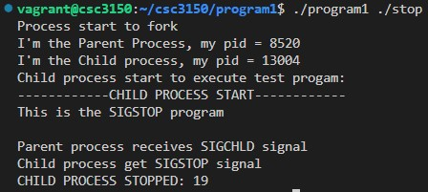

Stop

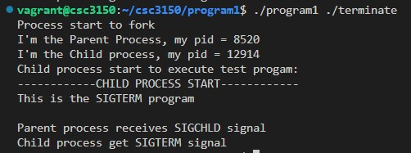

Terminate

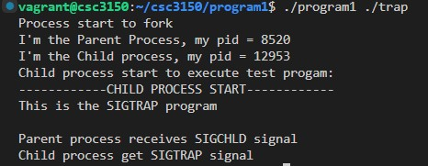

Trap

**Program 2:**

Four export file: fork.c, exec.c, exit.c, namei.c.

Four funcs: _do_fork, do_execve, do_wait, getname_kernel

Export method: use export symbol and then compile the kernel again

Program2_init is invoked by module_init().

Then the initialization function creates a new thread to run my_fork.

My_fork(), print out child process pid and parent process pid.

Then, call my_wait() to capture the return signal from child process.

Then, implement the child process in my_exec, the do_execve() executes the file in a given path. Return value can show wether it is succeed. If not, end child process by do_exit() and return the result. If succeed, return 0.

Then, back to parent process and implement my_wait and printk related information.

Below is the output graph:

